Name: ___________________

TRAPEZOID
A quadrilateral with at least one pair of parallel sides

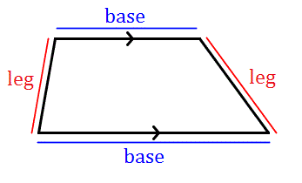

1. ____________________________________________________________________

2. ____________________________________________________________________

ISOSCELES TRAPEZOID
A trapezoid with congruent legs

**We know that an isosceles trapezoid is a trapezoid so it will have the two trapezoid properties, plus a few extra

1. ____________________________________________________________________

2. ____________________________________________________________________

PLUS:
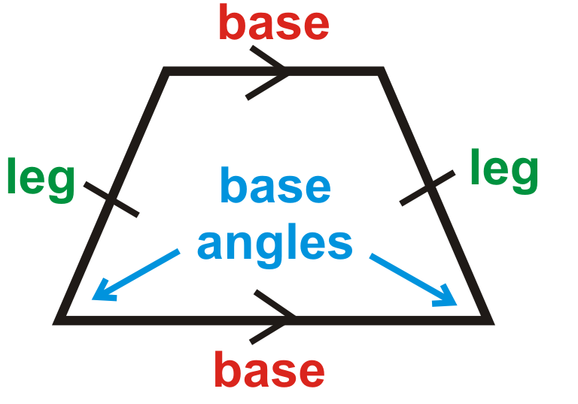

3. ____________________________________________________________________

4. ____________________________________________________________________

5. ____________________________________________________________________

Using the trapezoid and isosceles trapezoid properties, solve the following problems.

- In the diagram below, and are bases of trapezoid ABCD. If and , what is ?

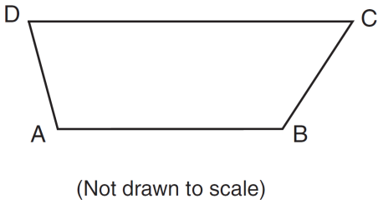

- In the diagram of trapezoid ABCD below, , , , and . What is ?
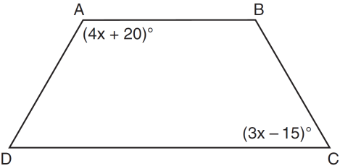

- The diagram below shows isosceles trapezoid ABCD with and . If and , find .

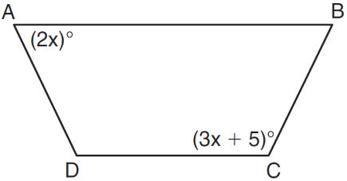

- In the diagram below of isosceles trapezoid DEFG, , , , , and . Find the value of x.

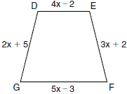

- Isosceles trapezoid ABCD has diagonals and . If and , what is the value of x?

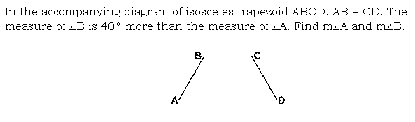
6.

7.

TRAPEZOID MIDSEGMENT

Explain in complete, coherent sentences what you learned about the midsegment of a trapezoid and how you find the length of the midsegment.

Use what you learned to answer the following questions:
- In the diagram below, is the median of trapezoid ABCD. If , , and , what is the value of x?

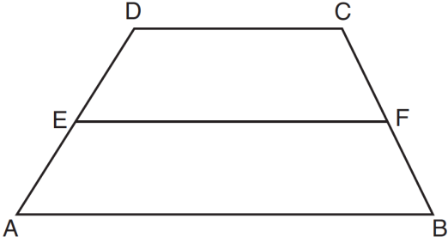

- In the diagram below of trapezoid RSUT, , X is the midpoint of , and V is the midpoint of . If and , what is the length of ?

PARALLELOGRAM
A quadrilateral with both pairs of opposite sides parallel

_______ _________________________________________

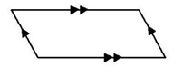 ________________________________________________

________________________________________________

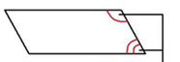 ________________________________________________

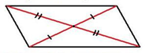 ________________________________________________

Using the parallelogram properties, solve the following problems.
1.

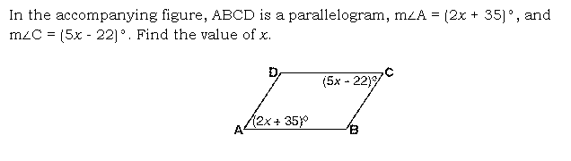
2.

3.

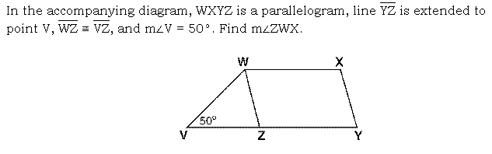
4.

RHOMBUS
A parallelogram with four congruent sides

1. ____________________________________________________________________

2. ____________________________________________________________________

3. ____________________________________________________________________

4. ____________________________________________________________________

5. ____________________________________________________________________

PLUS:
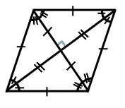

6. ____________________________________________________________________

7. ____________________________________________________________________

8. ____________________________________________________________________

Using the rhombus properties, solve the following problems.

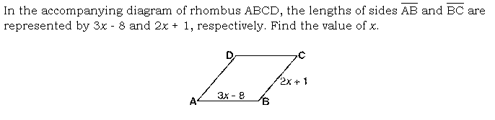
1.

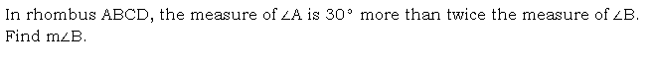
2.

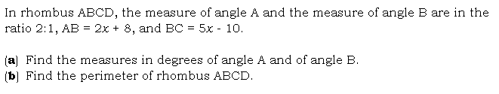
3.

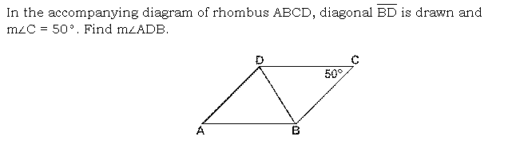
4.
5.
In the diagram below of rhombus ABCD, . What is ?
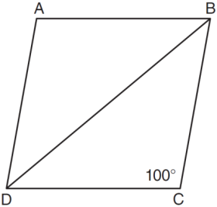
6.
In the diagram below, MATH is a rhombus with diagonals and . If , what is ?
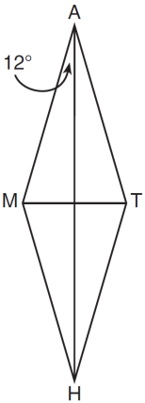
7.
In rhombus ABCD, the diagonals and intersect at E. If and , what is the length of ?
RECTANGLE
A parallelogram with four right angles

1. ____________________________________________________________________

2. ____________________________________________________________________

3. ____________________________________________________________________

4. ____________________________________________________________________

5. ____________________________________________________________________

PLUS:
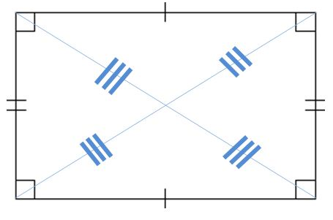

6. ____________________________________________________________________

7. ____________________________________________________________________

Using the rectangle properties, solve the following problems.
1.

2. As shown in the diagram of rectangle ABCD below, diagonals and intersect at E. If and , then the length of is?

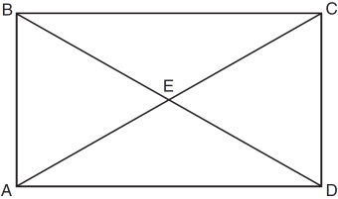

3.

SQUARE
A parallelogram with four congruent sides AND four right angles

1. ____________________________________________________________________

2. ____________________________________________________________________

3. ____________________________________________________________________

4. ____________________________________________________________________

5. ____________________________________________________________________

PLUS:

6. ____________________________________________________________________

7. ____________________________________________________________________

PLUS:

8. ____________________________________________________________________

9. ____________________________________________________________________

10. ___________________________________________________________________

Using the square properties, solve the following problems.
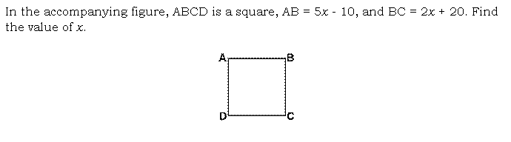

2. What is the perimeter of a square whose diagonal is ?

CUMULATIVE PROBLEMS:

- True or False: A square is a rhombus

- True or False: A rhombus is a square

- Which statement is true about all parallelograms?
[a] The diagonals are congruent.
[b] The area is the product of two adjacent sides.
[c] The opposite angles are congruent.
[d] The diagonals are perpendicular to each other.

4. Which property is true for all trapezoids?
[a] Only two opposite sides are parallel.
[b] Consecutive angles are supplementary.
[c] The base angles are congruent.
[d] All angles are equal.

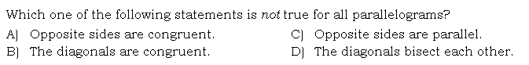
5.

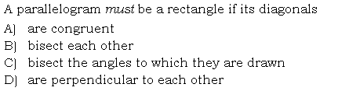
6.

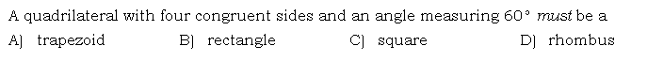
7.
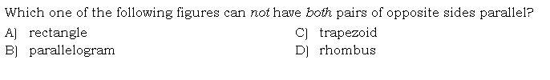
8.
5.
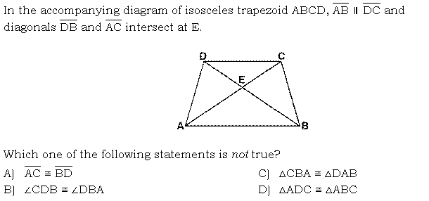
9.

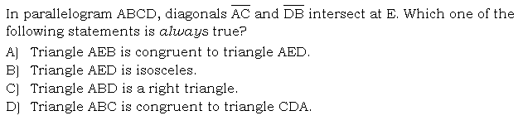
10.

11.

12. What is the perimeter of a rhombus whose diagonals are 16 and 30?

13. In rhombus ABCD, with diagonals and , . If the length of diagonal is 12, what is the length of ?
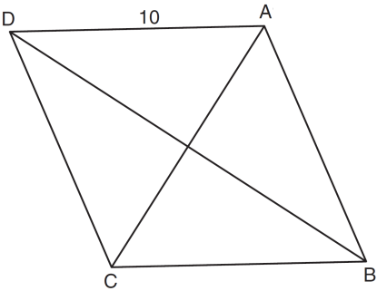

14. In the diagram below, quadrilateral STAR is a rhombus with diagonals and intersecting at E. , , , , , , and . Find SR, RT, and .

